**KRISHNA ENGINEERING COLLEGE** 

(Approved by AICTE & Affiliated to Dr. APJ Abdul Kalam Technical University (Formerly UPTU), Lucknow) **Department of**

**Computer Science and Engineering (Artificial Intelligence)**

**Data Structure using C Lab (KCS351)**

**Exercise-5: Write C Programs to illustrate the concept of Recursion and Iteration List of Experiments:**

1. Write a program in C to find factorial of a given number using iterative and recursive methods both.

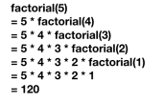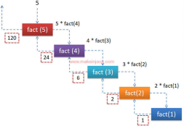2. Write a program in C to find Fibonacci series using iterative and recursive methods both. 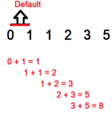

3. Write a program in C to implement multiplication of two natural numbers using recursion. 4. Write a program in C to implement the solution of Tower of Hanoi problem using Recursion.

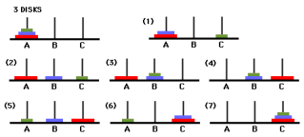

5. Write a program in C to implement the solution of Tower of Hanoi problem without using Tail Recursion.

6. Write a program in C to convert a decimal number to binary using recursion.